***Real-Time Early Response System For Safety***

***L-Rekha: Safety at your touch***

Rushabh Indresh Singh

Department of Computer Engineering

VESIT-Chembur

Mumbai, India

2015rushabh.singh@ves.ac.in

Mohit Sunil Sajnani

Department of Computer Engineering

VESIT-Chembur

Mumbai, India

2015mohit.sajnani@ves.ac.in

*Abstract* — The best way to measure the progress of nation is to evaluate how the nation treats its women. However, women in India and in several countries continue to face numerous problems including violent victimization through rape, acid attacks, dowry killing, kidnapping, indecency, eve teasing and all other crimes listed in the Indian Penal Code. This paper presents an intelligent safety system in the form of an Android application, which will provide necessary emergency help, preventive measures, escape from unnecessary conversations, situations, detection of hidden cameras, and prevention from exploitation, provide useful evidence, helpful in persecution of dowry, bribe asking; thus making a better, safe and harmonic environment for all the genders.

# Introduction

As Swami Vivekananda had said, “There is no chance of the welfare of the world unless the conditions of women are improved. It is not possible for a bird to fly on one wing.” However, the status of women is gradually deteriorating due to insult to modesty, kidnapping, sexual assault, abduction, cruelty by intimate partner or by relatives, trafficking, persecution of dowry, dowry deaths, indecency, etc. The National Crime Records Bureau reported that by 2020 the rate of crimes against women would exceed the population growth rate. It also reveals that crime against women is committed every 3 minutes, a woman is raped every 29 minutes, a dowry death occurs every 77 minutes, and one case of cruelty committed by either husband or relative of the husband occurs every 9 minutes. After the realization of women’s contributions to the development of the family in particular and the society as a whole, several attempts to empower women have taken effect and the process is going on.

The growing field of IOT reflects a fact that we are trying to connect the nearly all life aspects with Internet. One of the most important aspect of life is safety of yourself and your family members. In this paper, we are trying to connect the women’s safety measures with IOT via the automation technology in order to provide the 100% safe environment. This paper presents intelligence security system with required advanced technology to deal with the various scenarios like:

* Ragging, persecution of dowry, asking for bribe
* Risky situations while travelling alone
* Detecting hidden cameras
* Emergency help for ambulance, fire brigade,

Blood bank, ATM, police stations

* Getting instant help from nearby users to your location
* No need to worry in case of zero balance
* Sending your location to the registered contacts along with your message
* Getting out from uncomfortable situations
* Getting instant help from nearest police stations to your location
* Get attention in public places like for help
* Keep an eye on your loving ones

Since we cannot predict such incidents, hence it is better to keep all the helpful tools in one application to escape from any above circumstances.

# Features of l-rekha

**L-ert call:** If the user is in trouble or any kind of risky situations, he/she just needs to tap the L-ert option thrice and within a moment an alert call will be sent to his/her friends and family members as selected by user initially. Along with the alert call, they will be able to trace the location of user. While sending the alert call user can send his/her, message also if it is possible for the user. Otherwise, by default recorded message will get send in the alert call saying, "I am in trouble". Tapping thrice is for user's convenience because single or double tap may happen accidently. It will also display the list of emergency contacts on the screen like friends, family, ambulance, fire brigade, etc. so you can select multiple options as per the circumstances.

**2. L-Range:** If the user is in trouble and needs immediate help, by clicking the L-Range option he/she will be able to send the alert call to all the L-REKHA users within range of circle of radius 500 meters.

**3. Au-Vi**: In case of ragging, teasing, domestic violence, persecution of dowry, in case of asking bribe user can use Au-Vi option. It will directly start recording video/audio secretly i.e. the screen will turn off while recording video. It will save the video to the secured database and will mail to your accounts.

**4. Po-St:** There will be a Po-St option by clicking on which the app will trace the nearest police station to your location and an alert call and current location shall be reported automatically. However, this can be used only in case of emergency. It will also display the locations of nearest police stations on your screen so you can reach easily.

**5. De-Cam:** With the help of De-Cam option you will be able to detect the hidden cameras in the changing rooms or at any place. It will detect the infrared rays coming from any hidden cameras in hotel rooms, changing rooms, etc. You will be notified about the location of hidden cameras.

**6. Buzzer:** As the saying goes, "it is better to be safe than sorry". If the user is in a public place and feels uncomfortable with some stranger, he/she can use this option. Buzzer can be used to grab attention in public places/transport.

**7. L-Account**: In case if there is no balance in your account, you will not be able to send alert call although you have internet access in your phone. Thus to deal with the situation we bring the feature of self-account of L-Rekha which can be used in above unavoidable and undesirable situations. It can also take data loan if necessary. You can add money to L-account from your main balance, net banking, debit card, credit card and other online sources like Paytm.

**8. Follow Me:** It lets your friends and family members know your path to the destinations. With the help of follow me option you will be able to trace the path of your loving ones. You can know the last location of a user. It is also helpful in detecting lost phones. It converts your phone into a GPS tracking device. You can pre-enable it before going to unknown locations.

**9. Help:** If the user is in trouble and needs an emergency help he/she can use Help option. With HELP option you would be able to trace the nearest location of hospitals, fire brigade service, blood bank, child helpline, NGO etc. not only location but also he/she would be able to contact them.

**10. Fake Call:** Fake Call is the new trend and everyone seems to use it in style. So be in style and get out from undesirable situations just by clicking fake option. The Fake call helps the user to escape from unwanted conversations.

# Comparative research and analysis

|  |  |  |
| --- | --- | --- |
| **Apps** | **Important Features** | **Shortcomings** |
|  |  |  |
| 1. bSafe | SOS, Video Call,  Police  Notifications,  Integrated  Social Media | No Safe zone, No Location Based Crime Reporting, No Traffic Forecast, Double Tap Is Not Convenient |
|  |  |  |
|  |  |  |
|  |  |  |
|  |  |  |
|  |  |  |
|  |  |  |
|  |  |  |
|  |  |  |
| 2. VithU | SOS | No Police Phone Directory, Can’t Share Your Location, No Emergency Help |
|  |  |
|  |  |
|  |  |  |
|  |  |  |
|  |  |  |
|  |  |  |
|  |  |  |
|  |  |  |
| 3. VRBA | Voice Based Alert Call Even When Keypad Is Locked, Can Trace Your Location | App May Not Recognize The User If Noise Is There, Need To Remember The Keywords |
|  |  |
|  |
|  |  |
|  |
|  |  |
|  |
|  |  |  |
|  |  |  |
|  |  |  |
| 4. IPROB | Shaking The Mobile Above The Predefined Threshold Value Automatically Activates The System | User Should Remember The Shaking Way And Its Frequency To Activate The System |
|  |  |
|  |
|  |  |  |
|  |  |  |
|  |  |  |
|  |  |  |
|  |  |  |
|  |  |  |

# Technologies used

* **Platform:** Android
* **Coding Languages:** Java , XML
* Firebase Cloud Messaging
* Android Geofencing framework
* Firebase Real Time Database

# GUI Design

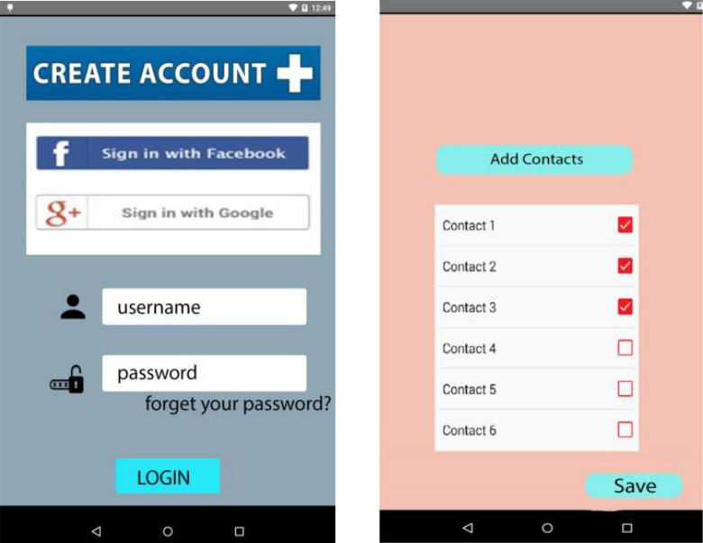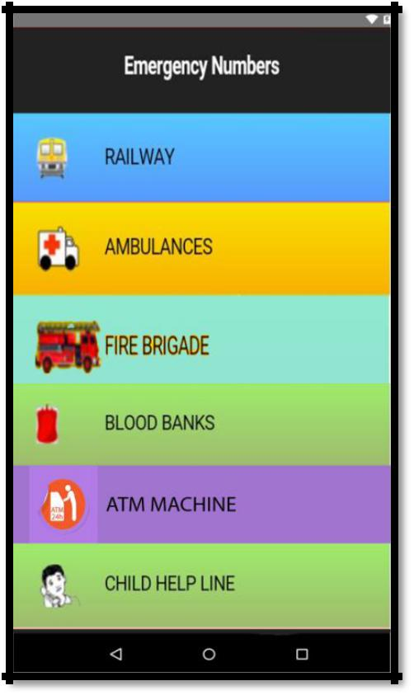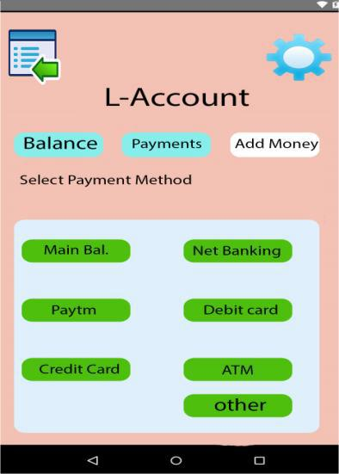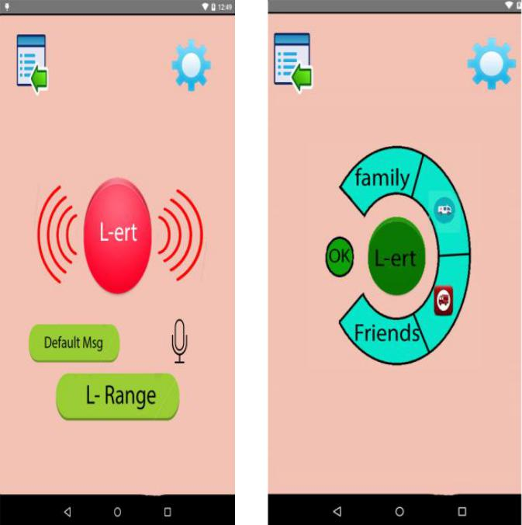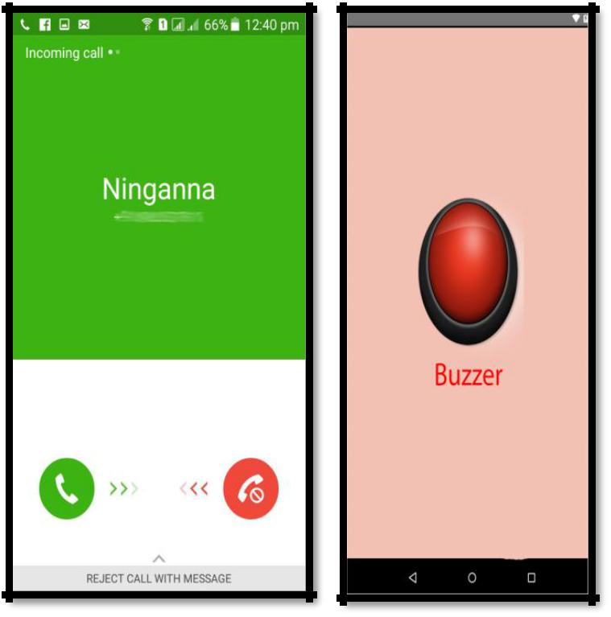

# Conclusion

With the help of L-Rekha, you will never feel helpless and will never walk alone. It provides preventive measures in case of all possible threats. It will also provide necessary emergency help for accidental situations and uncomfortable scenarios. It also helps to detect hidden cameras thus preventing you from being exploited. This paper provides useful insights on the application, which will be helpful in future not only for women but also for all classes of the society. It will allow women to work and roam freely in a safe environment thus building confidence in them.

# future scope

* As the technological changes or new requirements from users emerge, new versions will be made to enhance functionality. New modules, which enhance the system functionality, can be added without any major changes to the entire system.
* By keeping this ability of the product in mind, an incremental process model has been used to design and develop the system.
* Among the various modules few are identified, which couldn’t be included in the current system:

1. Primary School Children Safety
2. Mobile and Valuable Theft Safety
3. Vehicle Safety

# references

1. Report of the Fourth World Conference on Women. New York, United Nations, 1995 (A/CONF.177/20/Rev.1)

(http://www.un.org/womenwatch/confer/beijing/reports/, accessed 1 April 2013).

1. World Health Organization, “Global and regional estimates of violence against women: prevalence and health effects of intimate partner violence and non
2. Dongare Uma, Vyavahare Vishakha and Raut Ravina, “An Android Application for Women Safety Based on Voice Recognition”, Department of Computer Sciences BSIOTR wagholi, Savitribai Phule Pune University India, ISSN 2320–088X International Journal of Computer Science and Mobile Computing (IJCSMC) online at www.ijcsmc.com,Vol.4 Issue.3, pg. 216-220, March- 2015
3. MAGESH KUMAR.S and RAJ KUMAR.M, “IPROB – EMERGENCY APPLICATION FOR WOMEN”, Department of Computer science Sree Krishna College of Engineering Unai village Vellore (TN) India, ISSN 2250-3153 International Journal of Scientific and Research Publications, online at the link www.ijsrp.org , Volume 4, Issue 3, March 2014.
4. “bSafe, a safety app for Android and iOS” http://tech.firstpost.com/news-analysis/bsafe-a-safety-app-for-android-and-ios-223480.html
5. “VithU App specially for Girls Safety”
6. http://yupandnope.com/2013/09/17/vithu-app-for-girls-safety/
7. Vodafone ."Connected women :how mobile can support women’s economic and social empowerment.” report March 2014.